**Simscape Multibody 仿真建模**

Simscape可在 Simulink环境中迅速创建物理系统的模型，Simscape库中的块代表实际的物理组件。因此，可以构建复杂的多体动力学模型，而无需通过物理原理来合成数学方程。接下来总结下如何使用Simscape Multibody的物理建模模块来建立平衡步兵模型。

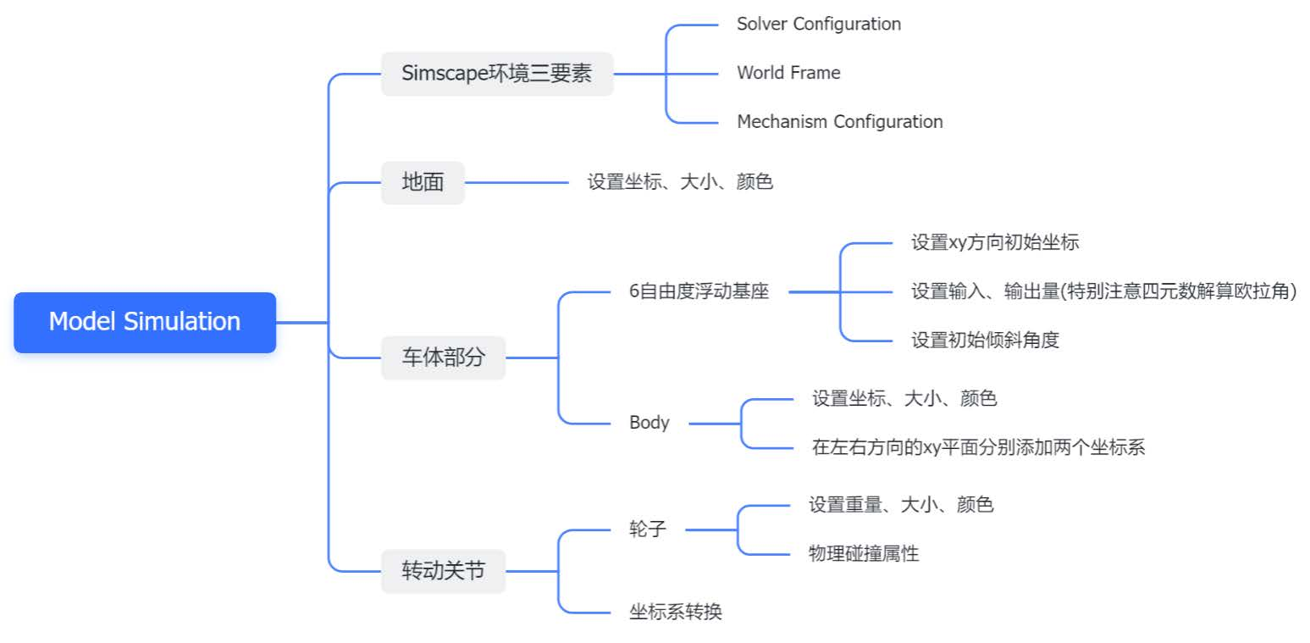

**Simscape搭建模型步骤**

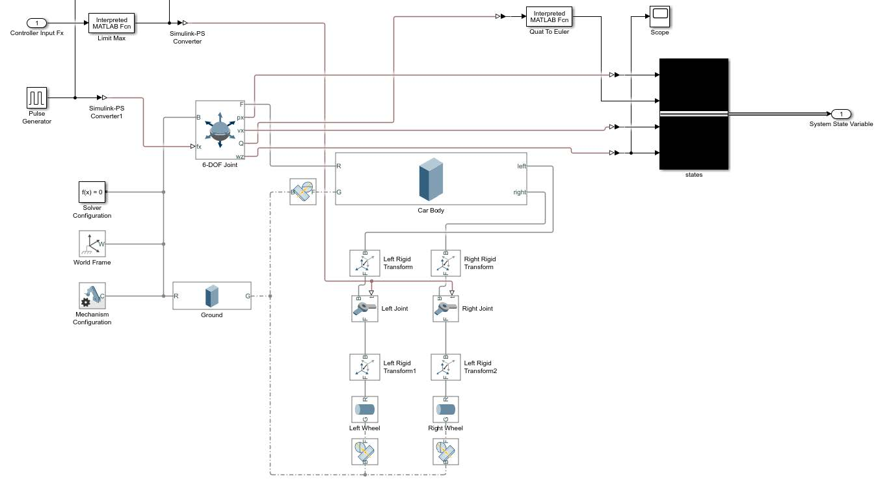

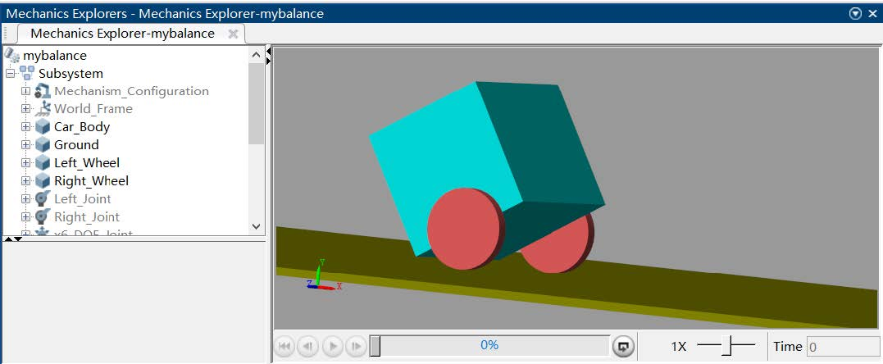

**Matlab脚本文件**

物理模型定义

|  |
| --- |
| clear;  clc;  %% 定义小车倒立摆物理性质  global m_wheel m M wheel_r l car_y g b n newrad gain_K Fx  wheel_r = 0.0925; %车轮的半径  l = 0.15; %摆杆质心到转轴距离  car_y = wheel_r+l-0.01; %simscape车体模型初始y坐标  m_wheel = 0.8; %车轮的质量  m = m_wheel*2; %倒立摆车体的质量  M = 15; %摆杆质量  g = 9.8; %重力加速度  b = 1e-4; %小车运动摩擦力系数  n = 1e-4; %摆杆旋转阻力矩系数  %% 状态空间矩阵  A = [0 0 1 0;  0 0 0 1;  0 m*g/M 0 0;  0 (m*g + M*g)/(M*l) 0 0];  B = [0;0;1/M;1/(M*l)];  C = eye(4);  D = 0;  %% LQR:  Q = diag([0.001 20 10 300]); % x q dx dq  R = 1; % fx  gain_K = lqr(A,B,Q,R)  gain_K = [0 -100 0 -2] |

将自由度关节输出的四元数转化为欧拉角，用来获取车身倾角

|  |
| --- |
| function Euler_Angles = Quat_To_Euler(quat)  % Rearrange the quaternion into the correct form [w, x, y, z]  Quat = [quat(1,1), quat(2,1), quat(3,1), quat(4,1)];  % Convert the quaternion to Euler angles using 'XYZ' order  Euler = quat2eul(Quat, 'XYZ');  % Extract the roll, pitch, and yaw angles from the Euler angles  Roll = Euler(1);  Yaw =Euler(2);  Pitch = Euler(3);  % Return the yaw angle as the output  Euler_Angles = Pitch;  end |

限幅函数

|  |
| --- |
| function out=LimitMax(intput)  out = intput;  If out>50  out = 50;  else if out<-50  out = -50;  end  end |

LQR计算函数

|  |
| --- |
| function Fx = LQRcalculate(states)  % Declare gain_K as a global variable  global gain_K  % Set the desired state  X_des = [0; 0; 0; 0];  % Calculate the control input using LQR control law  Fx = gain_K * (X_des - states);  end |